Postgres Joins: <http://www.postgresqltutorial.com/postgresql-joins/>

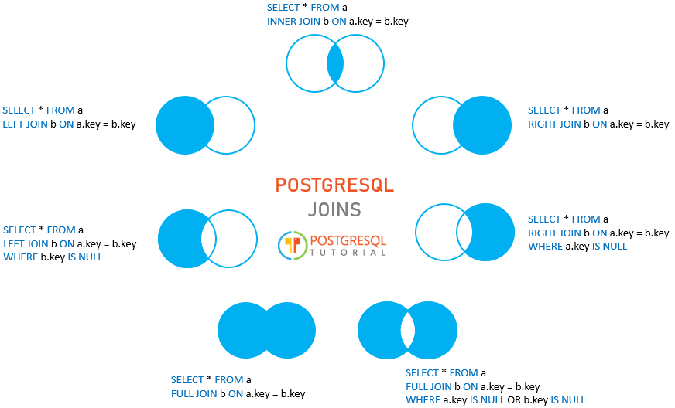

Query Optimization: <https://www.addictivetips.com/net-admin/sql-query-optimization-tools/>